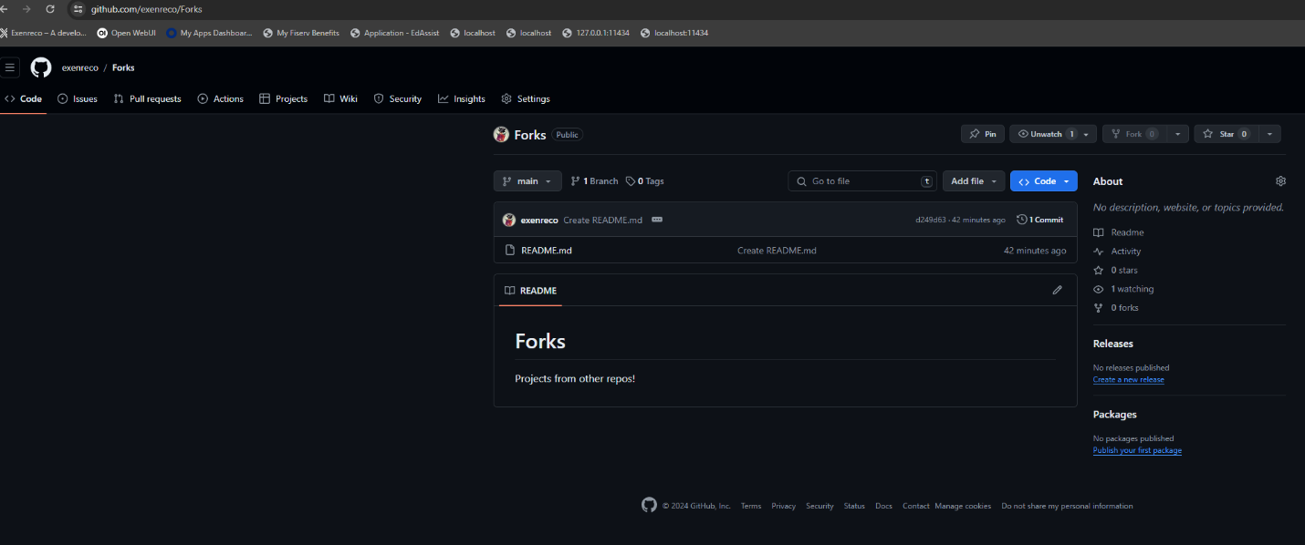

Created a new git repository, repo: <https://github.com/exenreco/Forks>

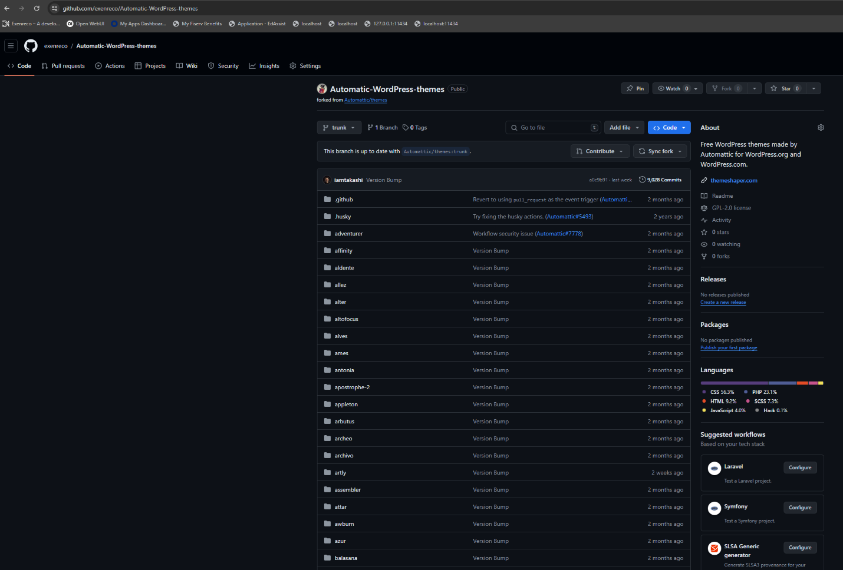

Fork a git repository, repo: <https://github.com/exenreco/Automatic-WordPress-themes>